Experiment : 5
Date:

CLASS DIAGRAM AND TIME SEQUENCE

Aim:
To study and implement object-oriented modelling concepts by designing a Class Diagram and a Time Sequence Diagram using Unified Modeling Language (UML). The experiment aims to represent both the structural framework and the behavioural flow of a system in a clear and systematic manner.

Objectives:
- To understand the fundamentals of UML diagrams.
- To identify classes, attributes, and operations in a system.
- To illustrate relationships among system components.
- To analyse interaction and message flow over time.
- To gain practical exposure to software design modelling.

Introduction
Unified Modeling Language (UML) is a standardized visual language used in software engineering for modelling, designing, and documenting systems. It acts as a bridge between conceptual design and actual implementation. UML diagrams simplify complex systems by presenting them in an organized graphical format.

Among various UML diagrams:
- Class Diagrams describe the static structure.
- Time Sequence Diagrams represent dynamic behaviour.
Together, they provide a complete understanding of how a system is built and how it functions.

Class diagram :

The class diagram represents the static structure of the system. It shows different classes, their attributes, methods, and the relationships between them such as association, inheritance, and aggregation.

Components of Class Diagram:
1. Class
Represents an entity or object in the system.
2. Attributes
Define the characteristics of a class.
3. Methods (Operations)
Specify the functions performed by the class.

Significance:
- Acts as a blueprint for system development.
- Helps in object-oriented analysis and design.
- Improves code reusability.
- Facilitates easy maintenance.
- Enhances system scalability.

By using a class diagram, developers can clearly visualize the architecture of the software and understand how objects are organized within the application.
This diagram helps in planning the system design before implementation and improves maintainability and scalability.
A Class Diagram is one of the fundamental structural diagrams in UML used to represent the blueprint of a software system. It provides a visual representation of classes, their internal structure, and the relationships that connect them. This diagram helps developers understand how the system is organized at a high level before actual implementation begins.
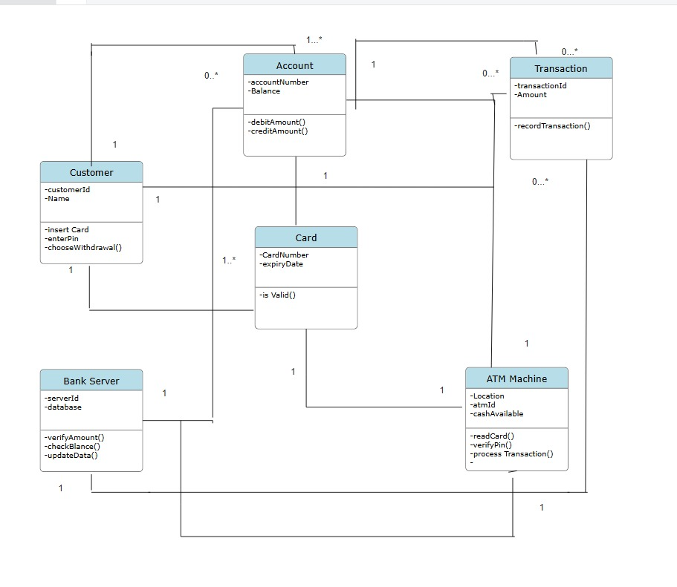

Time sequence diagram :

The time sequence diagram illustrates the dynamic behaviour of the system by showing the order of interactions between objects over time.

Key Elements:

- Objects / Lifelines – Participating entities.
- Messages – Communication between objects.
- Activation Bars – Duration of processing.
- Time Axis – Shows order of execution.

Functional Importance:

- Explains step-by-step system workflow.
- Illustrates message passing clearly.
- Helps in identifying logical flaws.
- Ensures proper sequencing of operations.
- Useful in real-time and event-driven systems.

Applications:
- Banking systems
- Library management systems
- ATM operations
- Online shopping platforms
- Student information systems

Advantages of UML Modelling:

- Simplifies complex designs.
- Improves communication among developers.
- Supports accurate documentation.
- Detects errors at early stages.
- Saves development time and cost.

It focuses on how messages are passed between components and how processes occur step by step during execution.
This diagram is useful for understanding system workflows, detecting logical errors, and ensuring that operations occur in the correct sequence.
It provides a clear view of communication between different parts of the system.
The Time Sequence Diagram plays a vital role in understanding the behavioural perspective of a software system.
It provides a clear visualization of interaction flow, execution timing, and system responses, thereby supporting developers in designing accurate, efficient, and well-coordinated software solutions.
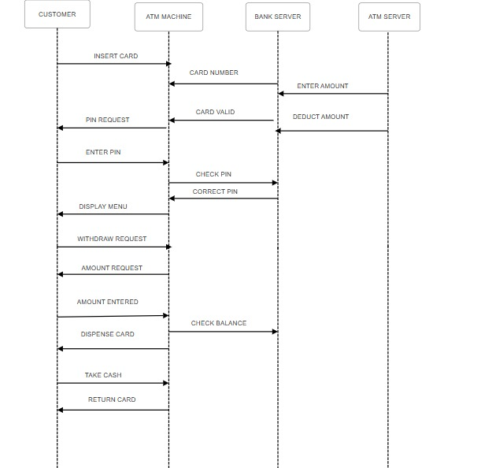

Conclusion:
Thus, the Class Diagram and Time Sequence Diagram were successfully designed using UML notations. Through this experiment, the structural organization and dynamic behaviour of the system were clearly understood. The activity improved knowledge of system modelling, design planning, and interaction flow. Overall, it emphasized the importance of UML diagrams in developing well-structured and efficient software systems.

